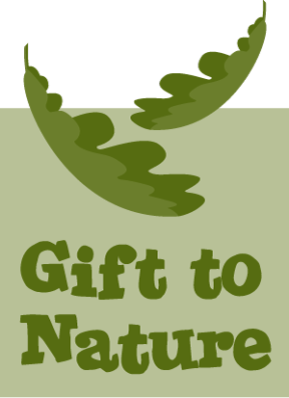
Gift To Nature Gift Aid Declaration

Boost your donation by 25p of Gift Aid for every £1 you donate

Please fill out this form and return it to info@gifttonature.org.uk or by post to the address below.

Gift to Nature is a part of the Island 2000 Trust. Gift Aid is reclaimed by the Island 2000 Trust charity from the tax you pay for the current tax year. Your address is needed to identify you as a current UK taxpayer.
In order to Gift Aid your donation you must tick the box below:
I want to Gift Aid my donation of £______________ and any donations I make in the future or have made in the past 4 years to the Island 2000 Trust.
I am a UK taxpayer and understand that if I pay less Income Tax and/or Capital Gains Tax than the amount of Gift Aid claimed on all my donations in that tax year it is my responsibility to pay any difference.

My Details
Title:
First name or initial(s):
Surname:
Full Home address:

Postcode:
Date:

Please notify the Island 2000 Trust if you:

- want to cancel this declaration
- change your name or home address
- no longer pay sufficient tax on your income and/or capital gains

If you pay Income Tax at the higher or additional rate and want to receive the additional tax relief due to you, you must include all your Gift Aid donations on your Self-Assessment tax return or ask HM Revenue and Customs to adjust your tax code.

Registered in England No. 3303358
Shide Meadows Centre| Shide Road | Newport| Isle of Wight | PO30 1HR
Part of the Island 2000 Trust, registered charity No 1083233

